Automated Infrastructure Damage Assessment (AIDA) Tool 1.0 Tutorial

This tutorial walks through step-by-step how to use the AIDA 1.0 tool, as well as explains the output files.

1. Open ArcMap.
2. Once ArcMap has loaded, click on the “Catalog” icon in the upper middle of the screen. 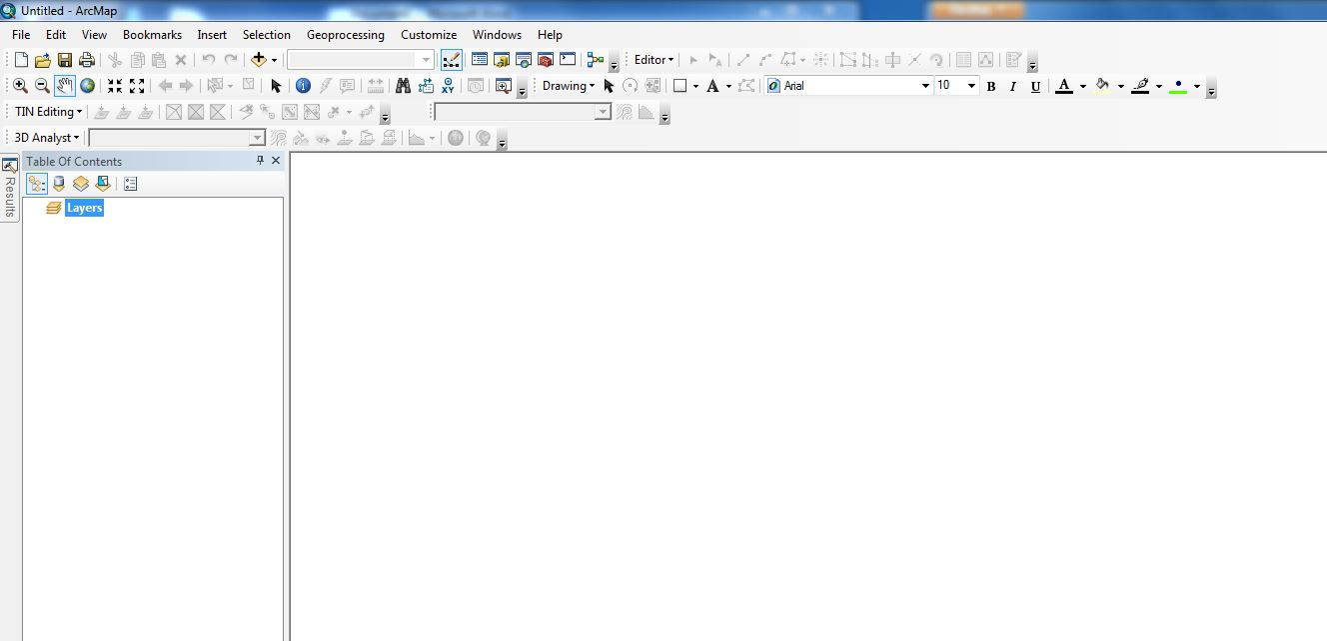

C:\Users\sbarron\Dropbox\JPL - Summer 2013\CA_MS Disasters and Water Resources\Weekly Science Advisor Meetings\Scott's Images\Tutorial_3.JPG

1. Once selected, locate the folder where the AIDA tool is located.

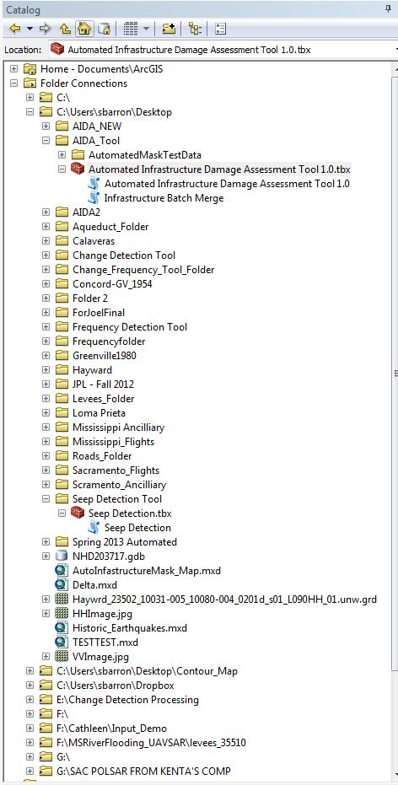

1. Once located, double click on the “Automated Infrastructure Damage Assessment Tool 1.0” script, located directly under the “Automated Infrastructure Damage Assessment 1.0.tbx”.
2. This should now bring up the input menu for the tool, which looks like this:

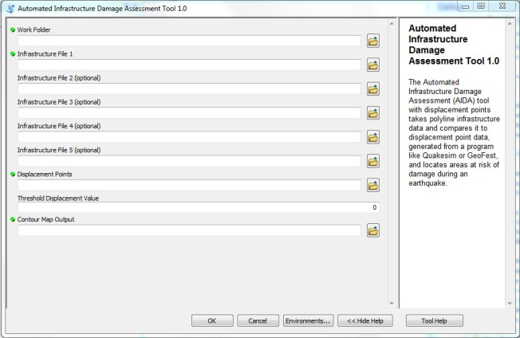

Notice the green dots to the left of the input names. These denote fields that are required by the tool. The other fields are labeled as “optional” and are not required to run the tool, however in order for the tool to run you do need to input a file into at least one of the “Infrastructure Files”.

1. Before running the tool, it is important to have all of your input files in one folder.

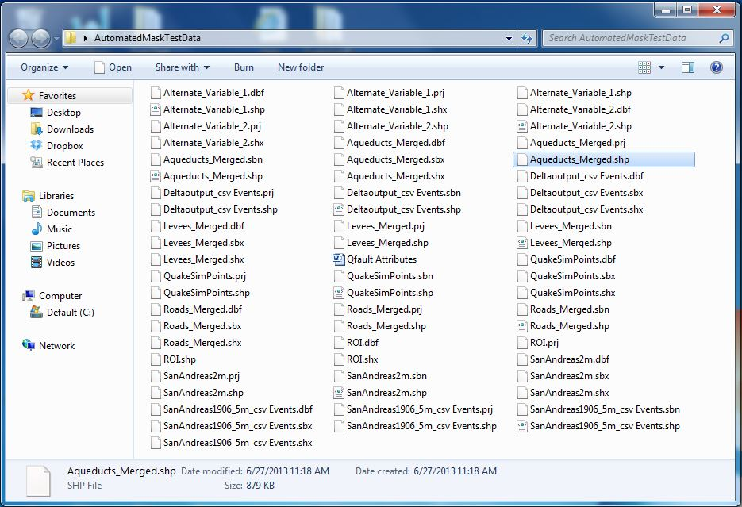

Here is an example of a folder set up for the AIDA tool, with all of the files to be used in one location.

1. Begin with the field “Work Folder”. This is the name of the folder where all of your data is located, as well as the location of your output data. In the example provided for step 6, the Work Folder is called “AutomatedMaskTestData”. You can easily select your input folder by clicking on the small folder icon to the right of the “Work Folder” field and then selecting your folder from the window. Once selected, click the “Add” button.

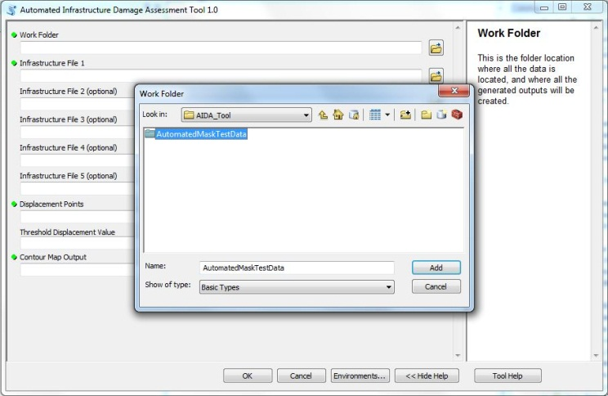

1. Repeat this process for however many of the following “Infrastructure File” fields you would like to use. If you used the “Batch Merge” tool included in the Automated Infrastructure Damage Assessment Toolbox, then the inputs for the “Infrastructure File” fields will be the outputs created from the “Batch Merge” tool. If you don’t want to use any of these five fields, just leave the input field blank.
2. The next input is the “Region of Interest”. If your study area is small and you would like to narrow the final results, include a shapefile here of the region you are interested in. If not, leave blank.
3. The next input is “Quakesim Points”. This is where you input the points file created by the Quakesim software. Note: for the tool to run, the points file needs to have a column in the attribute table called “totalDisp”. If it does not, the tool will not run as this is where it gets the displacement values from. If you would like to use displacement values from another source, look at the included tutorial “INSERT TUTORIAL NAME HERE”.
4. The next input field is the “Threshold Displacement Value”. This is the minimum displacement value you would like the tool to search for. This input is in millimeters. For example, if you know that roads become unusable after a displacement of 20 cm, then you would type “200” into the Threshold Displacement Value field and the tool will find all the sections of roads that intersect a region of at least 20cm of displacement.
5. The next input is “Damaged Infrastructure Output”. This is the name and location you would like to assign to the damage infrastructure file generated by the tool.
6. The last input is “Contour Map Output”. This is the name and location you would like to assign to the contour map generated by the tool.
7. Before running, your tool should look something like this:

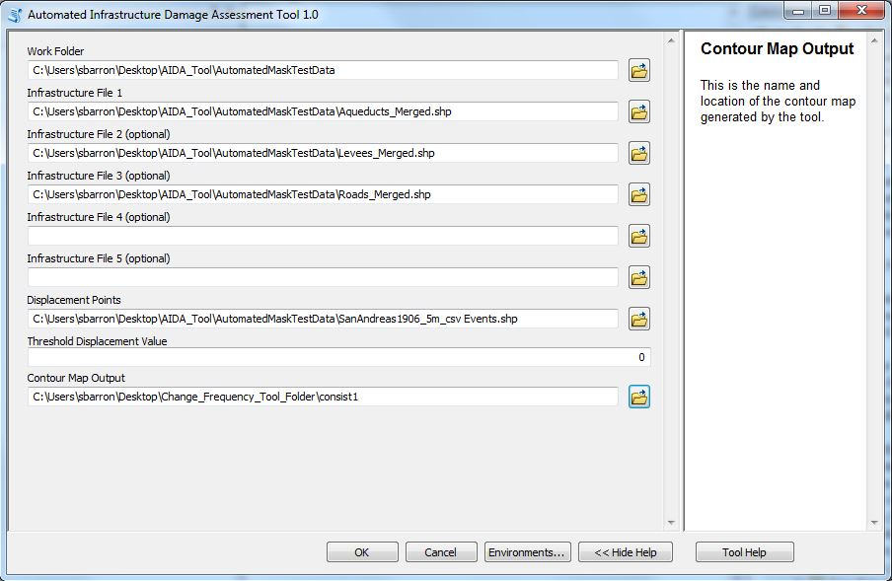

1. If you are satisfied with the inputs, then click “OK” and let the tool run. Depending on your computer’s capabilities, it should take a few minutes.
2. Once the tool is completed, click on the “Add Data” button as shown below and go to your work folder and select the information you wish to view. The damaged infrastructure files will be located in your “Work Folder” and labeled “Damage\_Infrastructure\_X” where X is the number of each Infrastructure field you used. You can also select the contour map generated by the tool based on the name you input into the “Contour\_Map\_Output” field.



C:\Users\sbarron\Dropbox\JPL - Summer 2013\CA_MS Disasters and Water Resources\Weekly Science Advisor Meetings\Scott's Images\Tutorial_10.JPG

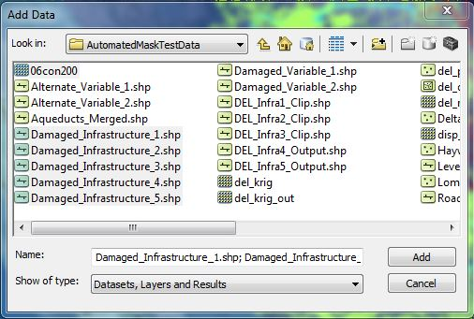

For this test run, 06con200 was the name of the generated contour map.

1. The “Damaged\_Infrastructure\_X” files show the infrastructure that intersects a displacement value higher than the “Threshold Displacement Value” you input into the tool.

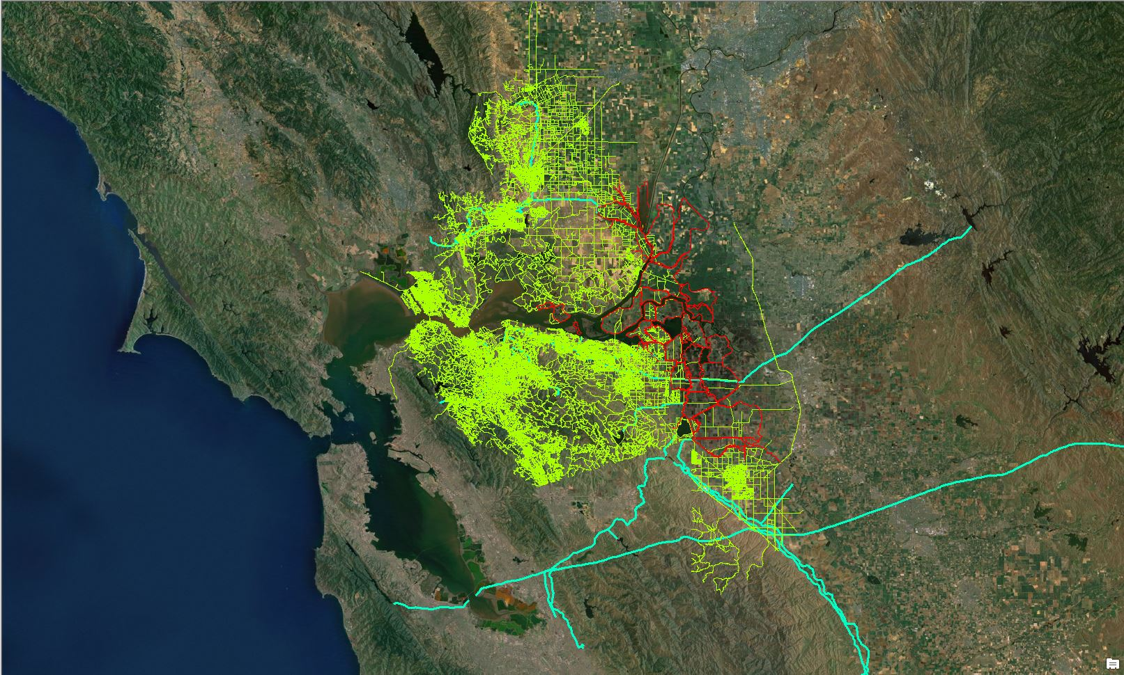

1. The contour map shows 5 different contours created by tool the: the Minimum, 25th percentile, Average, 75th percentile, and Maximum. Below are a sample contour map and its associated symbology. The symbology is not as straight forward as it first appears, however. Each of the values next to the different shades of blue represents the maximum value of that contour. For example. The darkest shade of blue, with a symbology value of “200”, represents a value range of 0 (the lowest possible displacement value) to 200. The next contour, labeled “775” represents a value range of 200 to 775. This continues all the way up to the last contour, with a value of “2,500” and which ranges from 1,925 – 2,500.

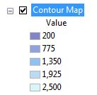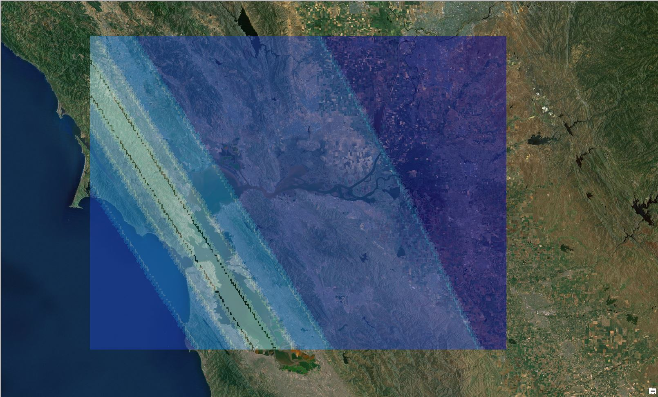

1. If you would like more information, you can add a basemap to your image to show by clicking on the small arrow next to the “Add Data” icon:

C:\Users\sbarron\Dropbox\JPL - Summer 2013\CA_MS Disasters and Water Resources\Weekly Science Advisor Meetings\Scott's Images\Tutorial_10.JPG

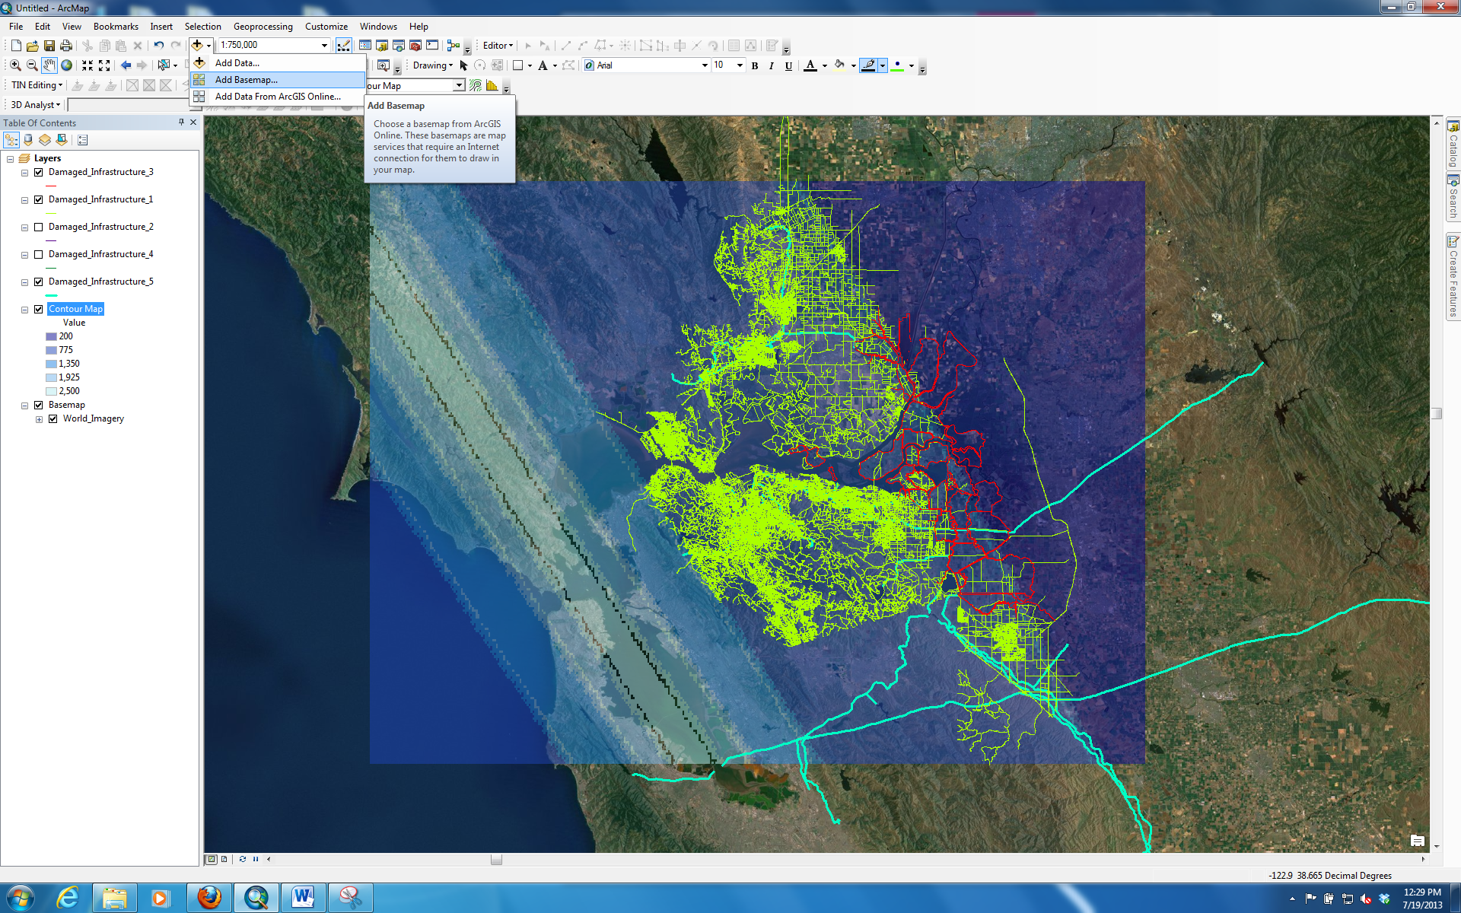

1. Finally, you will notice in your “Work Folder” that there are quite a few additional files created as a result of the process. Files that are of no importance are prefaced with “DEL\_” and can be deleted. If you would like, you can simply leave them in the folder. If you need to run the tool again, these files will be overwritten with the new data from the tool.